OpenERP OUTLOOK PLUG-IN USER GUIDE

First of all you need to set the configuration settings of OpenERP.

How to set the configuration of OpenERP in outlook?
- From Menu Bar, Open Tools -> OpenERP Configuration. Following dialog box will appear:
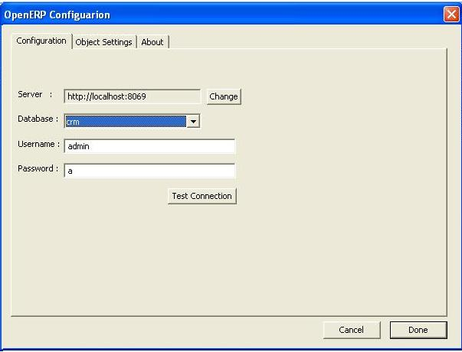

- In “Configuration” tab, default values for the server path, port, database name, username and password will be set for the localhost.

- To change the port and server you want to connect to click on button “Change”. Following dialog will appear:

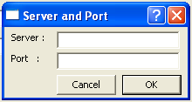

Click on “Ok” to connect to specified server at specified port which will bring you back to previous dialog box with list of databases on that server. Select the database you want to connect to and give proper username and password.

- Click on “Test Connection” to check
  - Whether specified server is running on given port,
  - Whether there exist any database on that server,
  - If yes, whether the username and password you have entered is correct or not.
  - On successful connection following Message box will appear:
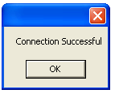

- Under “Object Settings” tab, default objects list will appear. You can add other objects to and even delete the selected object from list.

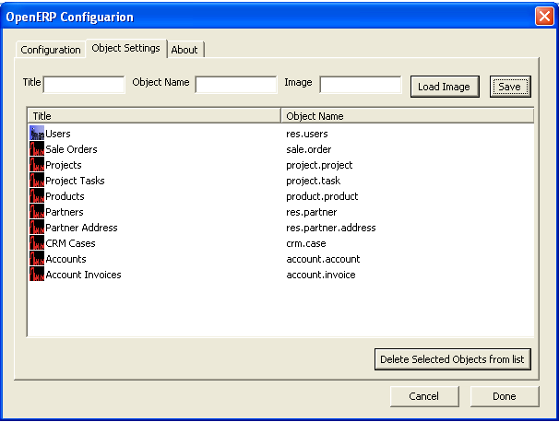

  - To add new object, give the new title for the object (titles should be unique), give the object name (it should not be already in the list) and image path (button “Load Image” will open a file browser, browse to the image path you wish to use for this object). In case you don’t specify any image-path, default image will be taken (OpenERP Logo).
  - To delete objects from the list, select the objects and click “Delete Selected Objects from list”

- In “About” tab, information about the plug-in is given

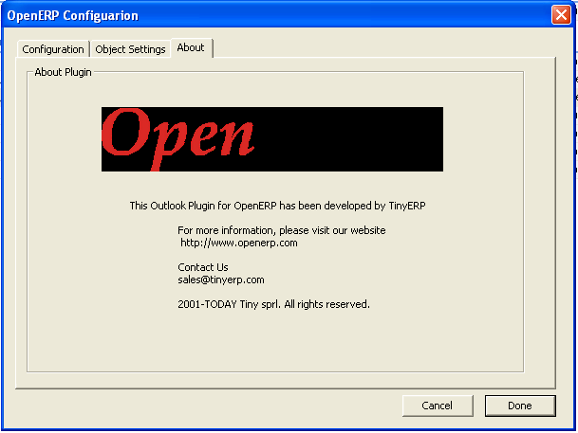

How to archive your emails to OpenERP?

1. From toolbar, clicking on “Archive to OpenERP”, following dialog box will appear:

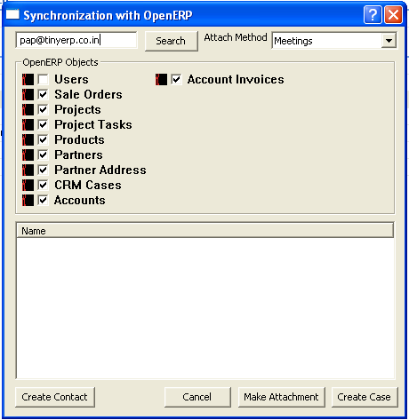

In this dialog box, the search box contains the email id of the sender of the email by default. You can edit it.
“OpenERP Objects” group box lists the objects configured in Configuration Settings with corresponding image and a checkbox with each object title.
Clicking button “Search” will search for the search_text in the field ‘name ‘, if any, of all the checked objects. Field ‘email’ is also searched for object “res.partner.address”. It will then fill the searched values in the listbox below.

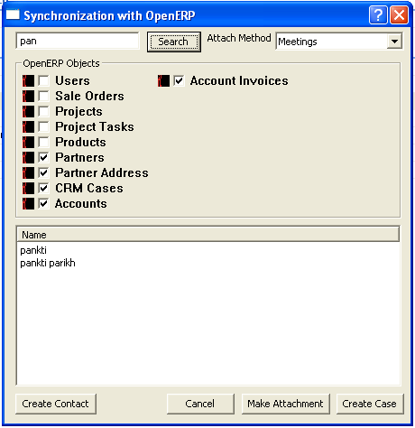

If none of the objects matches the search_text, alert window will appear as shown below:

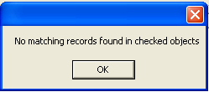

If user attempts to search record from any uninstalled objects then it will show an alert window as shown below. Eg. User was attempting to search from sale.order object, as it’s not installed its throwing the alert:

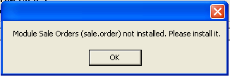

Now select the records you want to attach mail to and click on “Make Attachment”.
An ‘eml’ file will be generated which will be sent as an attachment to the selected records. Following notification box will appear on success:

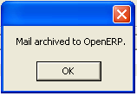

2. Create CRM Case :
For creating case, follow the steps as in “Make attachment”, select attachment method (Meetings, Leads, Opportunities etc) from dropdown list “Attach Method” and click on “Create Case”. To create a case for particular partner or partners, you need search for those partners and select them from the search list. Case will be generated for each of the selected “res.partner” objects.
On success, below Message Box will appear :

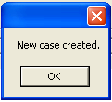

3. Creating a New Contact :
If none of the existing contacts match the search text, you can create the new contact. Click on “Create Contact” and you will see the dialog box as below.

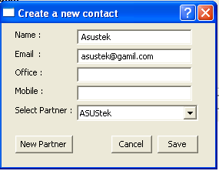

Enter the proper details; select the partner you want to create contact for and click “Save”. On success, following message box will appear:

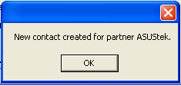

4. Creating a New Partner:
If the partner of you want to create contact for or archive the email to, does not exist you can create a new partner. For that click on “New Partner” and a new dialog will appear where you need to write the name of the partner and click “Ok”.

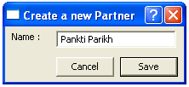

On success, following notification box will appear:

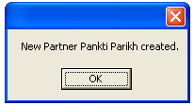

If there already exists a partner with this name, you will get an aler window saying “Partner already exist”

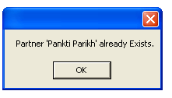

Enjoy Archiving the Outlook Email to OpenERP

